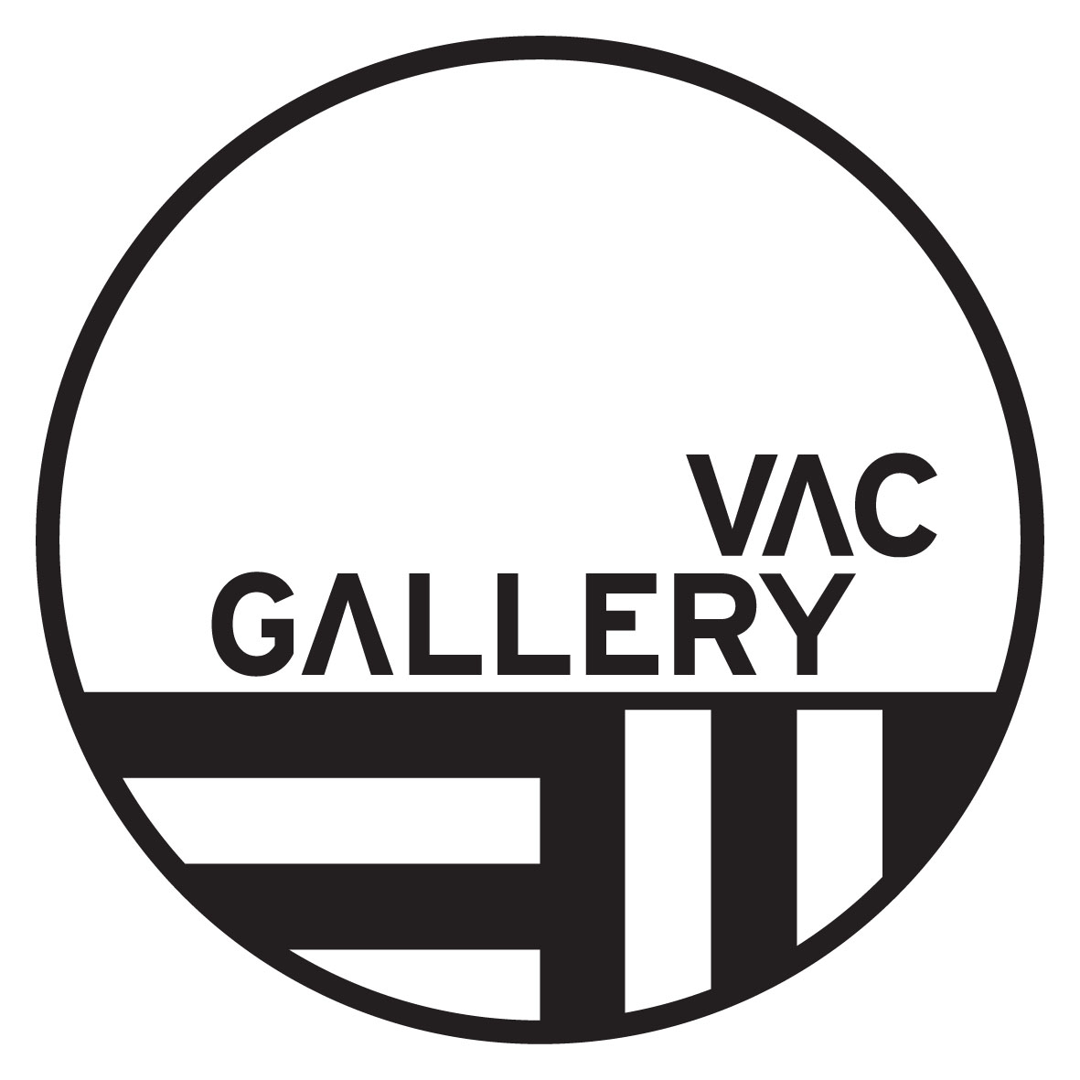

Exhibitor Registration Form

Exhibition Dates/Times | Street Style Melbourne photographer submission form  Launch: Early September 2017 (TBD)  VAC Gallery opening hours Mon-Fri: 9:00am – 5:00pm  And every second and last Saturday of the month
Picture Submission | This form should be submitted via email before  August 4, 2017  media@prov.vic.gov.au  Please use the email subject line: VAC gallery submission + ‘your name’  We will contact you directly for further correspondence
Venue | VAC Gallery  Victorian Archives Gallery  99 Shiel Street, North Melbourne

Submission Details
Name
Email
Contact phone number
Address

Please list images in order of preference
Picture ID  Name + 1,2,3 | Picture Title and URL Link | Image Size  Pixel Dimensions  Image size minimum 8MB  They will be printed at A1 (59cmx84cm)  300dpi | Orientation  Portrait/Landscape

All submitted image URLS must include the following details or the submissions will not be considered

Picture 1  Image title: | Location: | Year:

How does this image complement the theme of Street Style Melbourne? and also include your preferred image description.

Picture 2  Image title: | Location: | Year:

How does this image complement the theme of Street Style Melbourne? and also include your preferred image description.

Picture 3  Image title: | Location: | Year:

How does this image complement the theme of Street Style Melbourne? and also include your preferred image description.

All submissions must be made on the understanding that the photo may be used for publicity purposes. Full credits will apply. All prints from the exhibition will be available free of charge for the photographer when the exhibition closes (postage is not available you will need to pick it up or ask someone else to).

